**Use case Diagram:**

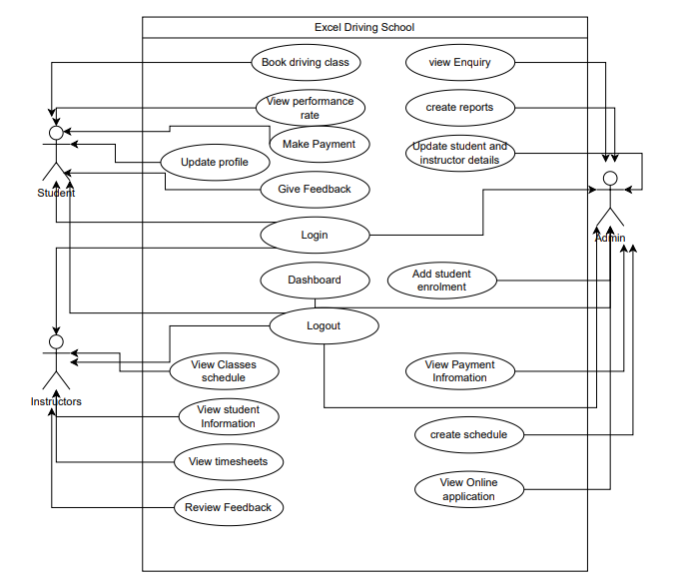

Fig: Use case of Excel Driving School